1. To use the ribbon commands, what menu and grouping of commands will you find the Insert and Delete command?

Ans: 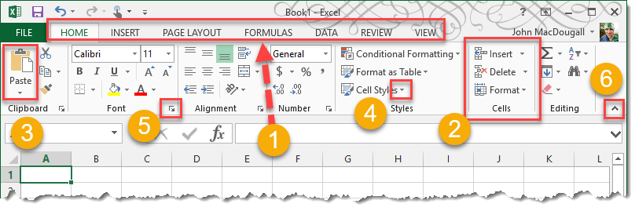

1. **Tabs** organize related groups of commands together.
2. **Groups** organize related commands together.
3. **Command Buttons** allows you to perform actions or open menus with further related actions.
4. **Command Menu** some command buttons will have a small down arrow located to the right or below the button. This indicates that a menu is available with sub-commands under the command button.
5. **Dialog Box** certain groups in the ribbon will contain a small icon in the lower right hand corner that will launch a dialog box with further options available.
6. **Pin or Unpin Toggle** allows you to remove the ribbon from view to create more workbook space.
7. If you set a row height or column width to 0 (zero), what happens to the row and column?

Ans: If we set a row height or column width to 0 (zero), the respective row or column will hide.

1. Is there a need to change the height and width in a cell? Why?

Ans: Yes. It is necessary to change width and height in excel to fit the data.

1. What is the keyboard shortcut to unhide rows?

Ans: First click and drag to the highlight the rows or columns or select entire sheet, then press **Ctrl+Shift+9.**

1. How to hide rows containing blank cells?

Ans: The process is given below:

1. Select the range that contains empty cells you want to hide.
2. On the Home tab, in the Editing group, click Find & Select > Go to Special.
3. In the **Go to Special** dialog box, select the **Blanks** radio button, and click OK.
4. Press Ctrl + 9 to hide the corresponding rows.
5. What are the steps to hide the duplicate values using conditional formatting in excel?

Ans: The steps are follows

1. Select range of cells
2. On the Ribbon's Home tab, click the Conditional Formatting button, then click New Rule
3. Click Use a Formula to Determine Which Cells to Format
4. Conditional Formatting
5. Then, from the first drop-down, choose Formula Is
6. For the formula, enter **=A2=A1**
7. Click the Format button.
8. Select a font colour to match the cell colour.
9. Click OK, click OK